

LAB REPORT

CSE416: Web Engineering Lab

|  |
| --- |
| 02 [Report Number] |

Topic: Design and Implementation of a Responsive Shopping Webpage using HTML5 and CSS3

Submitted To

**ENGR. NISHAT SADAF LIRA**

Lecturer

Department of CSE, Daffodil International University

Submitted By

Student ID: 221-15-4698

Section: 61_J1

Student Name: **Hossain Md Jakaria**

Date of Lab Report Submission: 20th August, 2025

**1. Objective**

The primary goal of this lab work is to design and implement a responsive shopping webpage using HTML5 and CSS3. The experiment aims to:

* Create a functional navigation bar with dropdown menus, search functionality, and a shopping cart icon.
* Design a banner section with a call-to-action button.
* Display multiple products in a grid layout with hover effects.
* Add a footer for webpage completeness.
* Implement interactivity and responsiveness through CSS hover effects, Flexbox, Grid, and media queries.

**2. Equipment and Software Used**

|  |  |  |
| --- | --- | --- |
| **Sl. No.** | **Equipment / Software** | **Description** |
| 1 | Laptop / PC | Used to code, test, and execute the web application |
| 2 | Visual Studio Code | Code editor for writing HTML and CSS |
| 3 | Google Chrome | Browser to preview and debug the webpage |
| 4 | HTML5 & CSS3 | Technologies used for structuring and styling |
| 5 | Font Awesome | External library used for adding the shopping cart icon |

**3. Theory / Background**

* **HTML5 (HyperText Markup Language):** Defines the structure of the webpage, including the navbar, banner, product cards, and footer.
* **CSS3 (Cascading Style Sheets):** Handles the visual design, such as layout, colors, fonts, spacing, and responsiveness.

Key concepts applied in this project:

* **Flexbox:** Used in the navbar to arrange elements neatly.
* **CSS Grid:** Used in the product section to align product cards responsively.
* **Hover Effects & Animations:** Applied to buttons, product cards, and images for interactivity.
* **Dropdown Menu:** Implemented in the navbar using nested HTML and CSS hover functionality.
* **Responsive Design:** Achieved using relative units, flexible layouts, and CSS properties suitable for different screen sizes.

**4. Procedure**

* **Navbar Design**
* Added a shop title (“Shop With Me”).
* Created navigation links with dropdown menus for Account, Items, and Offer.
* Integrated a search bar, search button, and Font Awesome cart icon.
* Styled with background color, hover effects, and spacing.
* **Banner Section**
* Inserted a promotional banner image with a background cover style.
* Added a “Shop Now” button positioned at the bottom-right with hover color change.
* **Product Grid Section**
* Designed a grid to showcase four product cards (Strawberry, Orange, Apple, Watermelon).
* Each card contains an image, product name, and price.
* Applied hover effects for scaling and smooth animation.
* **Footer Section**
* Added a footer with text credit (“All rights @Sadik5056”).
* Styled with alignment, margin, and background adjustments.
* **Styling and Responsiveness**
* Navbar and product cards styled with Flexbox and Grid.
* Search bar and buttons styled for better UI.
* Media queries used to make the layout adapt to mobile and tablet screens.

**5. Code Implementation**

The project consists of two main files:

* **HTML file:** Defines the structure of the webpage including navbar, banner, product grid, and footer.
* **CSS file:** Styles the webpage, implements hover effects, responsive grid, and dropdown menus.

HTML & CSS [[View Full Code on GitHub]](https://github.com/Sadik881583/Web-Engineering/tree/main/Lab-03)

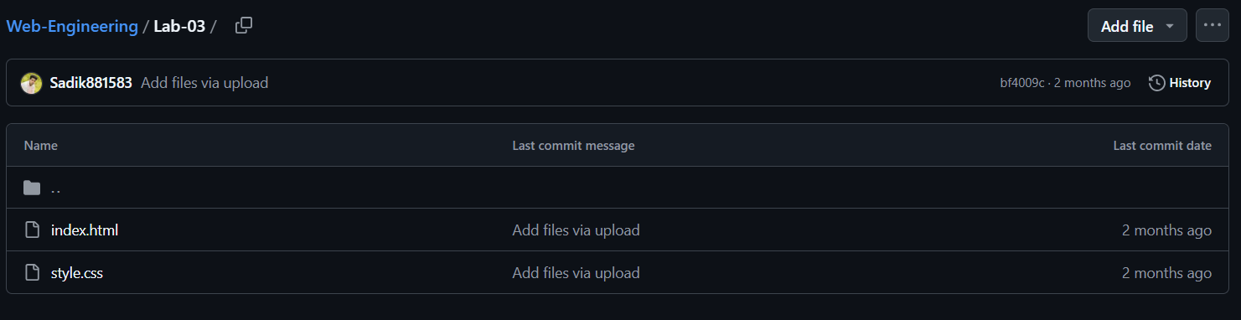

**6. Output / Observation**

After executing the code in a browser:

* A **black navigation bar** appeared at the top with the shop name, dropdown menus, search box, and shopping cart icon.
* The **banner section** displayed a background promotional image with a “Shop Now” button.
* The **product grid** showed four product cards with images, names, and prices. Hovering over the cards triggered zoom-in and lift effects.
* The **footer** displayed at the bottom with proper alignment.
* The webpage adapted well to smaller screen sizes, ensuring responsiveness.

Sample Output Screenshot:



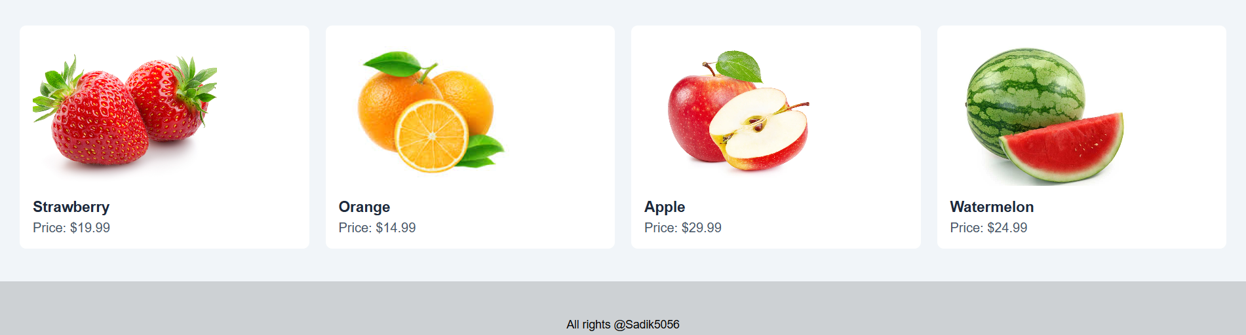

**7. Result**

A fully functional and visually styled shopping webpage was successfully created using HTML and CSS. The implementation of dropdown menus, hover effects, responsive grid layout, and styled components enhanced the user interface (UI) and user experience (UX).

**8. Conclusion**

Through this lab, we learned how to:

* Combine HTML5 structure with CSS3 styling.
* Implement Flexbox and Grid layouts for page arrangement.
* Apply hover effects and animations to make the page interactive.
* Use Font Awesome for icons.
* Create a responsive webpage that works on desktops, tablets, and mobile devices.

This exercise provided hands-on experience in designing professional, user-friendly webpages.

**9. References**

MDN Web Docs – <https://developer.mozilla.org/en-US/docs/Web/CSS>

W3Schools – <https://www.w3schools.com/css/>

Font Awesome – <https://fontawesome.com>